HEALTHCARE WELCOME KIT
EMAIL TEMPLATES

TABLE OF CONTENTS
Partner-to-End Users – Initial Notification
Partner-to-End Users – Call to Action
Partner-to-Partner Clients
Partner-to-Partner Customer Support

Partner-to-End Users – Notification

Goal: Explain to prescribers who ID.me is (trusted partner, etc.) with a focus on what we do in simple terms, and why they need to use us.

SUBJ: [Partner Name] + ID.me required to e-prescribe with [e-prescribing product name]*

Hello [name],

[Partner Name] has engaged ID.me, a federally-certified identity provider, to verify the identity of all prescribers using our platform. ID.me’s identity proofing and authentication processes meet the requirements mandated by the DEA’s Electronic Prescriptions for Controlled Substances (EPCS) standard, as well as federal and state e-prescribing regulations.

Soon, you’ll receive an [method of communication] to verify your identity via ID.me. Please complete the ID.me verification process in order to continue using our platform for e-prescribing [controlled substances]. The ID.me workflow is simple and straightforward, and the entire process should only take a few minutes.

We’ve attached a user guide that covers the online, do-it-yourself verification steps. However, if you have any trouble verifying on your own, you can instead choose to talk to a real person, based in the US, who is trained and certified to verify your identity on a video call. We’ve also included a second user guide that covers these steps.

Please keep in mind that prescribers only need to complete identity verification once with ID.me. After that, you can simply e-prescribe through our platform using secure multi-factor authentication (MFA).

Additionally, once you’re verified, you can login at all other ID.me partners, including over 500 government and commercial sector organizations, healthcare IT platforms, and retail brands.

If you have any questions, please reach out to [Partner Name and partner’s preferred email/phone #] or you can check out ID.me’s support page at help.id.me.

Partner-to-End Users – Call to Action

Goal: Direct end users to complete identity proofing with ID.me.

SUBJ: [Partner Name] + ID.me: Identity verification required to e-prescribe with [e-prescribing product name]*

Hello [name],

[Partner Name] has engaged ID.me, a federally-certified identity provider, to verify the identity of all prescribers using our platform in order to be compliant with the DEA’s requirements for EPCS as well as CMS, federal, and state e-prescribing regulations.

You must complete the ID.me verification process in order to continue using our platform for e-prescribing [controlled substances]. The ID.me workflow is simple and straightforward, and the entire process should only take about 5-10 minutes.

You must complete verification no later than [enter announced deadline here].

What you’ll need:
- Smartphone or Tablet
- Email address
- Photo ID: Driver’s License, Passport, Passport Card or State ID Card
- Social Security Number
- NPI Number

How it works:
- Create Account (or Sign In)
- Secure Account
- Verify Identity & Medical Credentials
- Complete Verification
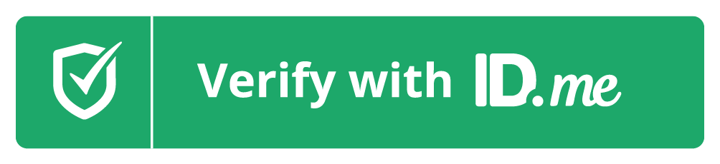
To Get Started, select ->

[hyperlink green button to identity proofing workflow starting point]

We’ve attached a user guide that covers the online, do-it-yourself verification steps. If you have any trouble verifying on your own, you may be asked to join a video call to complete verification. We’ve included additional information about ID.me’s video call.

Please keep in mind that prescribers only need to complete identity verification once with ID.me. After that, you can simply e-prescribe through our platform and login at all other ID.me partners, including over 500 government and commercial sector organizations, healthcare IT platforms, and retail brands.

If you have any questions, please reach out to [Partner Name and partner’s preferred email/phone #] or you can check out ID.me’s support page at help.id.me.

Partner-to-Partner Clients

Goal: Explain to partner clients what ID.me is, what regulations it satisfies, and why they need to encourage their end-practitioners to use it

SUBJ: [Partner Name] + ID.me required for prescribers to e-prescribe*

Hello [name],

[Partner Name] has engaged ID.me, a federally-certified identity provider, to verify the identity of all prescribers that utilize our platform for e-prescribing [controlled substances].

As you may know, the DEA’s Electronic Prescriptions for Controlled Substances (EPCS) standard, as well as federal and state e-prescribing laws, require identity proofing and authentication for e-prescribing services to protect against prescription abuse and fraud.

ID.me’s solution complies with these regulations while also making it simple for prescribers to complete the one-time verification process. Prescribers can either verify their identity via the online, do-it-yourself workflow or choose to join a video call with a real person, based in the US, that is trained and certified to verify identity.

In order for all healthcare facilities to be in compliance with applicable laws, it’s critical that prescribers complete the process. We’ve attached some documentation that fully explains ID.me’s solution as well as two user guides to pass on to your prescribers to help them navigate the do-it-yourself and video call processes.

Please inform your prescribers that they will receive an [method of communication] to complete the identity verification process in order to continue using our platform for e-prescribing.

If you have any questions, please contact us at [partner’s preferred email / phone#].

Partner-to-Partner Customer Support

Goal: Technical Explanation of ID.me - who we are, what we do, what they need to know to do their jobs (tech support)

SUBJ: [Partner Name] + ID.me - requirement for prescribers to e-prescribe*

Hello [name],

[Partner Name] has partnered with ID.me, a federally-certified identity provider, to verify the identity of prescribers using our platform. ID.me’s identity proofing and authentication solution complies with the DEA’s Electronic Prescriptions for Controlled Substances (EPCS) standard, as well as federal and state e-prescribing regulations.

As a result, it is critical that our prescribers are able to easily verify through ID.me. While ID.me offers its own robust support, we anticipate that some prescribers will reach out to [Partner Name’s] support for assistance.

What does ID.me do?
ID.me is ONLY being used for identity verification for e-prescribing purposes. If you receive a question referencing ID.me in relation to any other feature of our platform, please inform the prescriber that ID.me is not used for that feature and assist them with appropriate resources. To learn more about ID.me’s features, read the attached “Who is ID.me?” brochure.

Common Questions
User Experience: Prescribers will receive an [method of communication] to verify their identity via ID.me, which starts a simple and straightforward one-time verification process. This simple workflow should take less than five minutes. Please view the attached user guide to see the process that prescribers will go through and use it to answer any questions they may have.

Trouble with Verification: Determine if they are seeing a button to verify via video call. If they are, encourage them to click that button and then help guide them through the video call steps outlined in the second attached document.

Privacy Concerns: Some prescribers may be concerned with the personal information being requested by the ID.me platform. All of this information is required for secure identity proofing. ID.me is protected by advanced encryption and never distributes user data without explicit consent.

If you are unable to provide assistance to the prescribers, please send them to ID.me Support via [the established agent to agent Support Process].

